Features of the Magneto-Optical Structure of a Multifunctional Figure-8 Ring
S. D. Kolokolchikov(https://orcid.org/0000-0002-4218-1319)^{a,b,*}, A. E. Aksentyev^{a,b,c},
A. A. Melnikov^{a,b,d}, Yu. V. Senichev^{a,b}

ªInstitute for Nuclear Research RAS, Moscow, Russia,
^{b}Moscow Institute of Physics and Technology, Dolgoprudny, Russia,
^{c}Moscow Engineering Physics Institute, Moscow, Russia,
^{d}Institute for Theoretical Physics L.D. Landau, Chernogolovka, Russia
*e-mail: sergey.bell13@gmail.com
Abstract—The article presents a fundamental approach to figure-8 ring structure for multiple physical programs. Firstly, the unique shape of the ring resolves the issue of spin resonance crossings during the acceleration of a polarized beam. Secondly, this structure can be used for Electric Dipole Moment (EDM) measuring experiments and axion search. Thirdly, the structure can be adapted for heavy-ion beam acceleration.

Keywords: figure-8 ring, polarized beam, spin resonance, electric dipole moment

INTRODUCTION
The figure-8 ring is of interest in several areas of accelerator physics. First, in the context of collider experiments with polarized beams, there arises the problem of crossing various types of spin resonances, which lead to beam depolarization. The figure-8 ring eliminates this problem through mutual compensation of spin precession in arcs induced by the Magnetic Dipole Moment (MDM). As a result of this compensation, the spin tune becomes equal to zero, and the ring becomes spin-transparent (ST) [1], i.e., free of resonances.
In collider mode, the case of a polarized proton beam is considered. Here, the challenge of overcoming the transition energy arises. To solve this problem, a resonant structure with momentum compaction factor variation is employed [2]. With this approach, the transition energy is raised above the working energy of the experiment and can even reach complex value. A lattice with quadrupole gradient modulation in the figure-8 ring has been proposed.
The second potential application of the figure-8 structure is the measurement of the Electric Dipole Moment (EDM) and search for axions. The figure-8 ring has an advantage when used as a broadband axion antenna in the low-frequency range of the g-2 precession [3]; however, for EDM measurements there are difficulties: a pure figure-8 ring does not accumulate the EDM signal. This problem is solved by installing pairs of solenoids and Wien filters in its straight sections. In this case, the deuteron EDM can be measured using the quasi-frozen spin (QFS) method [4].
Since the installed solenoids convert the figure-8 ring into a racetrack-like structure from the spin dynamics point of view, it is necessary to solve the common problem of spin decoherence in such rings. The arc design including three independent sextupole families has been proposed to suppress decoherence of the polarized beam.
The third potential application of the structure is operation in the heavy-ion mode. Here, the key requirement is to achieve a long beam lifetime. For this purpose, the effect of intrabeam scattering (IBS) must be compensated by electron and stochastic cooling, which can be effectively achieved in a structure with minimal modulation of the Twiss functions.

PROTON MODE
According to the T-BMT equation [5], the beam polarization undergoes precession in a transverse magnetic field relative to the momentum direction with a relative frequency (spin-tune) $ν_{s}=γG$, where $γ$ the is Lorentz factor, $G$ is anomalous magnetic moment. Since in a figure-8 ring the main vertical magnetic field has opposite directions in the two bending arcs, the spin precession in one arc is completely compensated by the other, for particles at any energy. Thus, the spin tune equals zero, and the ring possesses the property of spin transparency. This eliminates the need to cross spin resonances during the acceleration of a polarized proton beam, which is a key advantage for preserving polarization in the experiment.
During proton beam acceleration, however, the transition energy issue should be solved to preserve a phase stability. In general, the transition energy is defined by the momentum compaction factor (MCF) and is proportional to the integral over the length of the ring:
$$α=\frac{1}{γ_{tr}^{2}}=\frac{1}{C}\int_{0}^{C}{ }\frac{D\left(s\right)}{ρ\left(s\right)}ds, (1)$$
where $C$ is the length of the accelerator, $D\left(s\right)$ is horizontal dispersion function, $ρ\left(s\right)$ is the radius of curvature of the orbit, $s$ is the longitudinal coordinate. For the figure-8 ring, the opposite orientation of the guiding magnetic field is expressed mathematically as a change in the sign of both curvature and dispersion. However, their ratio retains the same sign, meaning that the behavior of the momentum compaction factor is similar to that in a classical ring. The transition energy increase is possible by varying both dispersion and curvature. For a superperiodic modulation of the quadrupole gradient, the MCF to first order is given by [6]
$$α_{s}=\frac{1}{{ν_{x}}^{2}}\left\{1+\frac{1}{4\left(1-S/ν_{x}\right)}{\left(\frac{\overline{R}}{ν_{x}}\right)}^{4}\left.\frac{g_{k}^{2}}{{\left[1-(1-S/ν_{x})^{2}\right]}^{2}}\right\}\right., (2)$$
where $ν_{x}$ is the horizontal tune, $\overline{R}$ is the average curvature, $k=1$ is the order of expansion, $S$ is the number of superperiods and $g_{k}$ is the $k$-th harmonic of the Fourier decomposition of the gradient modulation. The regulation of the MCF is determined by the ratio $S/ν_{x}$. The optimal choice is 4 superperiods and a phase advance of 3. This ensures the first and second order achromat property. Dispersion is suppressed due to the choice of an integer number of betatron oscillations. Nonlinear effects of the first and second superperiods are suppressed by the third and fourth due to the chosen phase advance $π$.
The bending arcs of the figure-8 ring additionally rotate the momentum by an angle $α$, which accordingly increases the arc length. The length of the straight sections, depending on the bending angle, is given by $L_{ss}=D_{ring}∙\operatorname{ctg}{α}$ and the distance between the bending arcs is $L_{rt}=D_{ring}/\sin{α}$ as if it was a racetrack-shaped ring, as shown on Fig. 1. For convenience, in this work the angle was chosen to be 45 degrees. The layout of the elementary FODO cells of the structure is shown in Fig. 2, where the two edge cells provide an additional bend. The chosen number of superperiods determines the number of cells, and hence the effective magnet length for a given magnetic field. In this work, we suppose the maximum dipole field $B_{dip}=1.8$ T. The magnetic rigidity is determined from the final beam energy and the charge-to-mass ratio $Bρ=\frac{A}{Z}\frac{p_{0}}{c}$, where $A$ is the mass number, $Z$ is the charge number, $c$ is the speed of light, $p_{0} = βγM_{u}$ is the momentum, $M_{u}=931.494$ MeV/u is the atomic mass unit. For protons ($A/Z=1$) at the energy of 12.4 MeV ($γ=14.36$), the magnetic rigidity is $Bρ=44.5$. Thus, the average orbit curvature is $ρ=24.7$ m and the bending arc length is $L_{B}= 116.4$ m. Including technical gaps and quadrupole magnets, the total arc length is $L_{arc}= 167$ m. The length of a single magnet is $L_{mag}= 242.8$ cm. The layout of the elements with optimized straight section length is shown in Fig. 3.
The Twiss parameters are shown in Fig. 4 for the resonant structure with increased transition energy. In the considered case, the modulation depth $H=\left(G_{QF1}-G_{QF2}\right)/G_{QF1}=36\%$ and the transition energy is $γ_{tr}=54.7$. For each specific experiment, these values are chosen according to its requirements.

QUASI-FROZEN SPIN MODE
For EDM measurements, it is necessary to accumulate the EDM component while compensating the MDM component. In a pure magnetic ring, suppression of the MDM can be achieved by the quasi-frozen spin structure. In this case, elements with electric fields must be used, and straight static Wien filters with crossed magnetic and electric fields are employed to preserve a straight orbit. In figure-8 ring, suppression of the MDM component occurs automatically, but accumulation of the EDM component does not. To accumulate the signal, Wien filters and solenoids must be used in each straight section.
Another important requirement for EDM measurements is a suppression of decoherence [7]. This is achieved by minimizing the deviation of the equilibrium energy level from the effective energy:
$$Δδ_{eq}=\frac{γ_{s}^{2}}{γ_{s}^{2}α_{0}-1}\left[\frac{δ_{0}^{2}}{2}\left(α_{1}+\frac{3}{2}\frac{β_{s}^{2}}{γ_{s}^{2}}-\frac{α_{0}}{γ_{s}^{2}}+\frac{1}{γ_{s}^{4}}\right)+\frac{π}{2L}\left(ϵ_{x}ν_{x}+ϵ_{y}ν_{y}\right)\right], (3)$$
where $γ_{s}$ is the Lorentz factor of the reference particle, $α_{0}, α_{1}$ are the first and second order terms of the momentum compaction factor, $δ_{0}$ is the momentum spread, $L$ is the ring circumference, $ν_{x}, ν_{y}$ are the betatron tune. The above equation underscores the necessity of employing three independent sextupole families to correct the orbit lengthening due to longitudinal and betatron motion. One family should be placed at the dispersion function maximum to correct the second-order momentum compaction factor. The other two should be placed at the $β$-function maximum to correct chromaticity. For a magnetic figure-8 ring, it is assumed that a high coherence time is achieved a priori, even without sextupoles [8]. However, using a complex field configuration for EDM signal accumulation with Wien filters and solenoids requires corresponding sextupole correction [9]. Figure 5 presents a schematic representation of a regular arc, which allows for the arrangement of three linearly independent families of sextupoles. The dispersion suppression at the arc edges is achieved by a tune shift equal to $3×2π$.
Furthermore, the figure-8 ring has advantages for axion searches. Since the spin tune is approximately zero for any particle type and any energy, it provides significant prospects for using a proton beam in a figure-8 ring with a Wien filter setting the spin precession frequency. In this way, the ring can be used as an axion antenna to probe axion-like particles of low masses.

HEAVY-ION MODE
Important challenge for heavy-ion ring with high intensity beam is to ensure a sufficient lifetime. Due to the high particle charge, the influence of intrabeam scattering (IBS) is critically important and leads to emittance increase and the luminosity of collider experiment decrease accordingly. The characteristic IBS time in the horizontal plane depends on beam and lattice parameters [10]:
$$\frac{1}{τ_{x}}=\frac{π^{2}r_{0}^{2}v_{c}m^{3}N\left(log\right)}{γΓ}\left[\frac{γ^{2}\left(D_{x}^{2}+β_{x}^{2}ϕ_{x}^{2}\right)}{ϵ_{x}β_{x}}\right]\int_{0}^{∞}{ }\frac{dλ λ^{\frac{1}{2}}\left[a_{x}λ+b_{x}\right]}{{\left(λ^{3}+aλ^{2}+bλ+c\right)}^{\frac{3}{2}}}, (4)$$
where $r_{0}$ is the classical radius, $β$ and $γ$ are relative speed and Lorentz factor $v_{c}=βc$, $ϵ_{x}$ is the horizontal emittance, $N$ is the number of particles, $\left(log\right)= \ln\left(\frac{r_{max}}{r_{min}}\right)$ is the Coulomb logarithm, $Γ=(2π)^{3}(βγ)^{3}m^{3}ϵ_{x}ϵ_{y}σ_{δ}σ_{z}$ is the six-dimensional phase space volume, $ϕ_{x}≡D_{x}^{'}-\frac{β_{x}^{'}D_{x}}{2β_{x}}$, $β_{x},D_{x},β_{x}^{'},D_{x}^{'}$ are the beta-function, dispersion and its derivatives, respectively, coefficients $a, b, c, a_{x},b_{x}$ are defined in different ways in different models. Such calculations are implemented in simulation programs, for example, MADX [11].
The general approach in this case is to minimize the beta-function and dispersion as well as their regularization, which leads to the IBS time increase in the structure. This effect can be achieved by using fully regular bending arcs. However, to match with straight dispersion-free sections, dispersion suppression is required at the edges, which breaks regularity in that region. The most effective suppression method is the missing magnet scheme [12]. Less effective suppression can be achieved by varying the gradient of quadrupoles in the two or three edge cells.
Since in this work the multifunctionality of the structure is considered, the element layout is assumed fixed, and the second suppression method is analyzed. This approach has been studied in the design of dual-purpose structure [13]. Figure 6 shows the Twiss parameters for a heavy-ion structure. Due to the inefficiency of the chosen method for dispersion suppression, characteristic peaks occur at the edges of the arc, which ultimately reduces the performance of the IBS time. The average value of dispersion, depending on the dipole field integral, has the most significant effect. For each specific study, optimization of the lattice is required.

CONCLUSION
The features of the magneto-optical structure of a figure-8 ring have been considered. A possibility of using the ring for various physics programs has been demonstrated. For polarized proton beam, a method of transition energy increase in the resonant structure has been proposed. For EDM measurements in a Quasi-Frozen Spin structure, the introduction of three independent sextupole families for equilibrium energy level correction has been implemented. For heavy-ion beam, optimization of intrabeam scattering time has been studied.
The proposed applications of the figure-8 ring, along with its unique properties for polarized beams, make such a facility unique.

FUNDING
The study was supported by a Russian Science Foundation grant № 25-72-30005, https://rscf.ru/project/25-72-30005/.

CONFLICT OF INTEREST
The authors declare that they have no conflicts of interest.

REFERENCES
- Ya. S. Derbenev et al. Polarization Preservation and Control in a Figure-8 Ring, Int.J.Mod.Phys.Conf.Ser. 40 (2016) 01, 166009 DOI: 10.1142/S2010194516600909
- Senichev, Y.V., Chechenin, A.N. Theory of “Resonant” lattices for synchrotrons with negative momentum compaction factor. J. Exp. Theor. Phys. 105, 988–997 (2007). DOI: 10.1134/S1063776107110118
- N.N.Nikolaev, Spin of protons in NICA and PTR storage rings as an axion antenna. JETP Lett. 115, 639–643 (2022). DOI: 10.1134/S0021364022600653
- Yu.Senichev et al., in ICAP2015 Proccedings, Shanghai, 2016, ed. by C.Kwok, R.W.Volker, T.Chuanxiang, Y.Heping
- V.Bargmann, L.Michel, V.L.Telegdi, Precession of the Polarization of Particles Moving in a Homogeneous Electromagnetic Field. Phys. Rev. Lett. 2, 435 (1959). DOI: 10.1103/PhysRevLett.2.435
- Senichev, Y.V., Chechenin, A.N. Construction of “resonant” magneto-optical lattices with controlled momentum compaction factor. J. Exp. Theor. Phys. 105, 1141–1156 (2007). DOI: 10.1134/S1063776107120060
- Melnikov, A.A., Senichev, Y.V., Aksentyev, A.E. et al. Nature of Spin Decoherence of a Polarized Beam of Light Nuclei in a Storage Ring for EDM Search. JETP Lett. 118, 710–717 (2023). DOI: 10.1134/S0021364023603019
- R. Suleiman, Ya. Derbenev, M. Grau, V. Morozov, Particle accelerator spin-transparent storage rings for beyond state-of-the-art science, DOI: 10.18429/JACoW-IPAC2024-WEAN2
- A. Melnikov, S. Kolokolchikov, A. Aksentyev et al., Investigation of Spin-Decoherence in a Figure-8 Ring to Search for CP-Violation Sources, Phys. of Part. and Nuc. Let., this volume.
- J.D. Bjorken, S.K. Mtingwa, “Intrabeam Scattering,” Part. Acc. Vol. 13, pp. 115–143 (1983).
- F. Antoniou, F. Zimmermann, Revision of Intrabeam Scattering with Non-Ultrarelativistic Corrections and Vertical Dispersion for MAD-X, № CERN-ATS-2012-066
- B. Autin, Dispersion Suppression with Missing Magnets in a FODO Structure Application to the CERN Antiproton Accumulator, IEEE Trans.Nucl.Sci. 26 (1979) 3493-3495, DOI: 10.1109/TNS.1979.4330077
- S. Kolokolchikov, Yu. Senichev, A. Aksentev, A. Melnikov, Features of dual-purpose structure for heavy ion and light particles, Nuc. Sci. and Tech., DOI: 10.1007/s41365-025-01791-4

FIGURE CAPTIONS
Fig. 1. A schematic diagram of an 8-shaped ring for various deflection angles.
Fig. 2. Schematic diagram of a bending arc consisting of 12 cells formed in 4 superperiods.
Fig. 3. The layout plan elements of the figure-8 ring.
Fig. 4. Twiss functions of a resonant structure consisting of 2 arcs with different curvature and two straight sections.
Fig. 5. Twiss functions of a regular structure optimized for an EDM experiments.
Fig. 6. Twiss functions of a regular structure optimized for heavy ions in terms of increasing the time of intra-beam scattering.

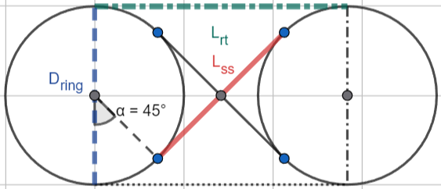
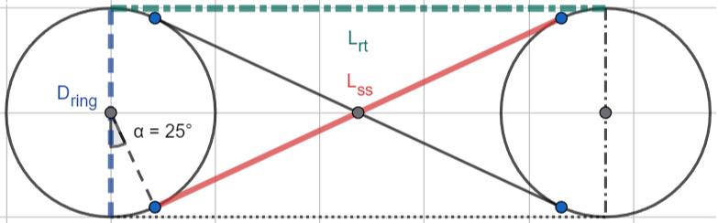
FIGURES
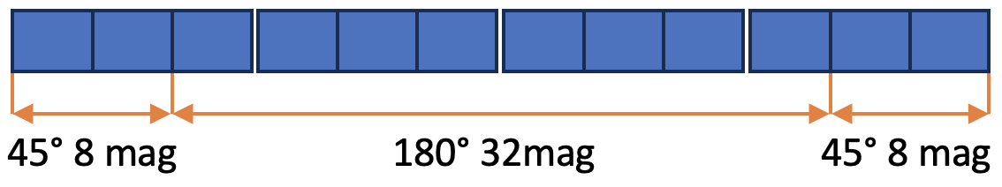
Fig. 1.
Fig. 2.

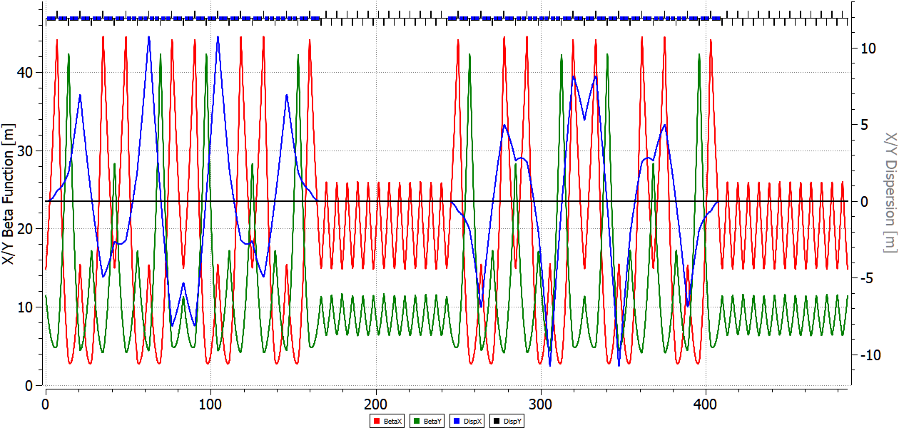
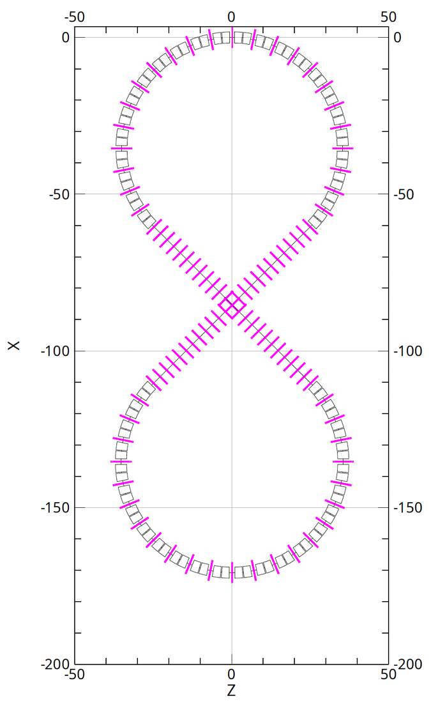
Fig. 3.
Fig. 4.

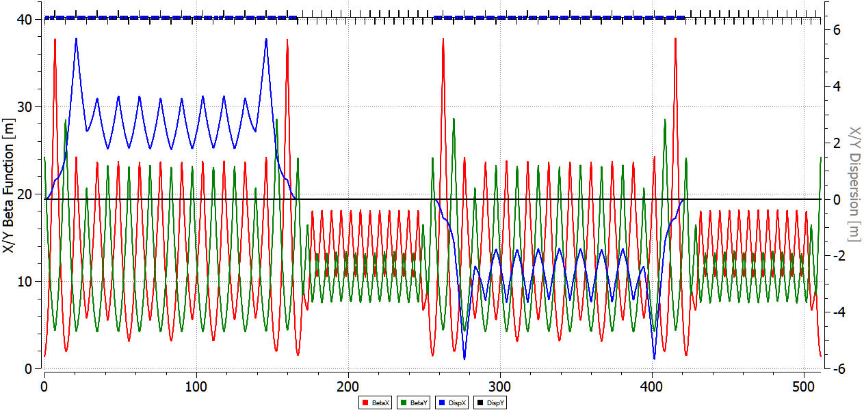
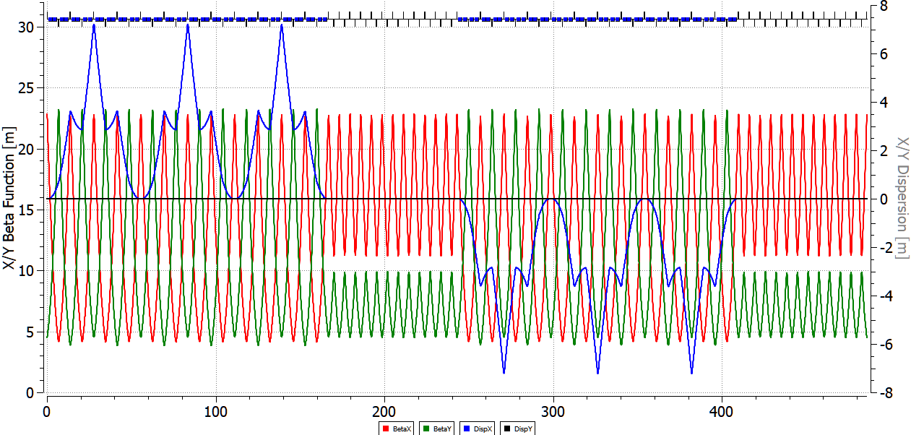
Fig. 5.
Fig. 6.

